**Temperature alarm**

# 1. Learning goals

In this lesson, we will learn to use the micro:bit on board buzzer and thermometer. Micro:bit will detect the motherboard chip temperature in real time. When the chip temperature exceeds a certain value, the buzzer will sound an alarm.

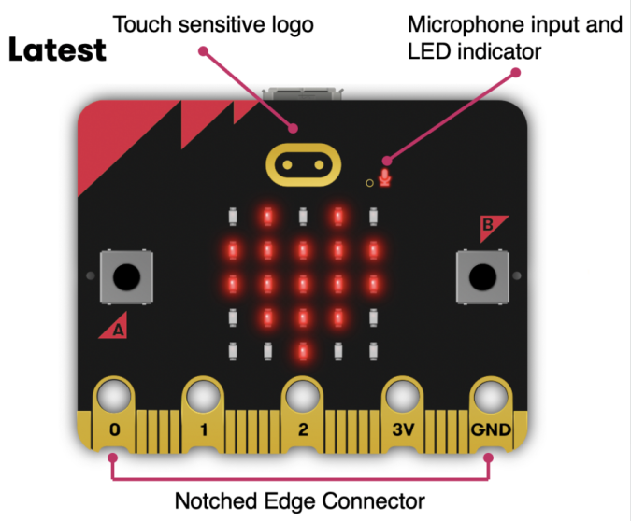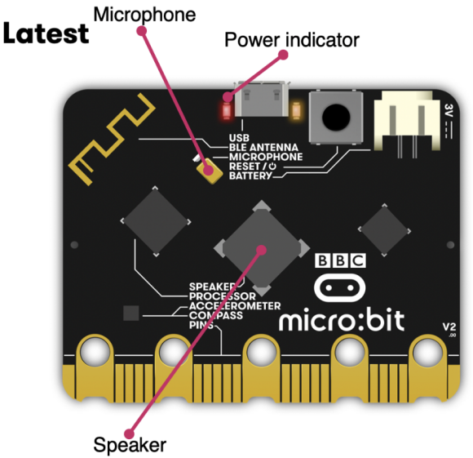

1. **Mode 1 online programming:**

First, we need to connect the micro:bit to the computer by USB cable. The computer will pop up a USB flash drive and click on the URL http://microbit.org/ in the USB flash drive to enter the programming interface to start program.

**Mode 2 offline programming:**

We need to open the offline programming software. After the installation is complete, enter the programming interface, click【New Project】, you can start program.

**3.Looking for blocks**

The following is the location of the building blocks required for this programming.

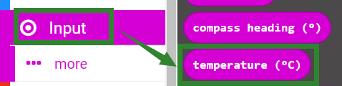

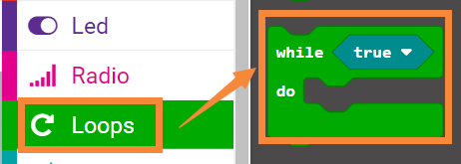

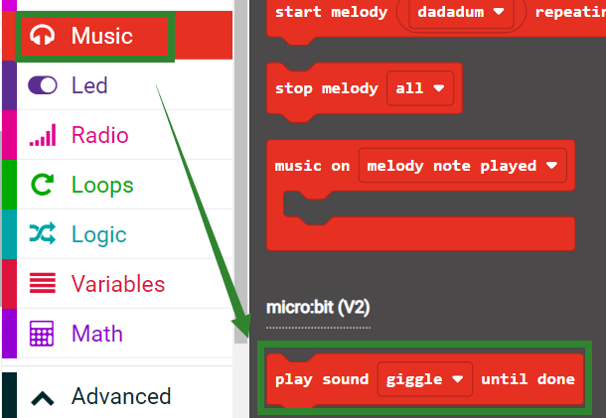

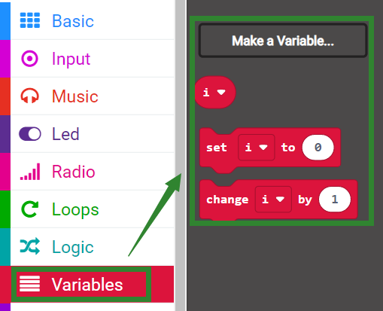

**4.Combine block**

The summary program is shown below.

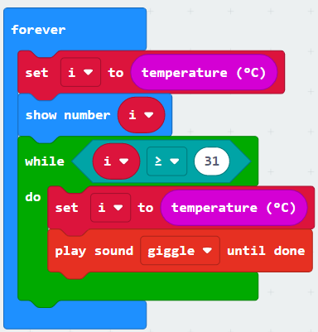

**Program analysis:**

Set the temperature value to the variable "i" and display it on the LED dot matrix. When the chip temperature is greater than 31 ℃, the alarm sound effect will be played.

You can modify the temperature threshold according to the current use environment by yourself.

**5.Experimental phenomena**

After connecting the computer to the micro:bit board via the micro USB data cable. Click download or save on the programming interface, and the program can be successfully downloaded to the Micro:bit board.

We can see the micro:bit dot matrix displays the current temperature.

For example, my current temperature is 29 ℃. After a while, the temperature of the Micro:bit chip will reach 31 ℃. At this time, the buzzer will sound an alarm. Place the Micro:bit board in front of the fan. When the temperature of the board drops, the buzzer will stop the alarm.